

**The Return of the Credit Cycle: Old lessons in New Markets**

Speech given by

Sir John Gieve, Deputy Governor, Bank of England

At the Euromoney Bond Investors Congress, London 27 February 2008

1

All speeches are available online at [www.bankofengland.co.uk/publications/Pages/speeches/default.aspx](http://www.bankofengland.co.uk/publications/Pages/speeches/default.aspx)

# Introduction

The turmoil in credit markets since August has been novel in some ways; but in others, the longer it has gone on the more familiar it has seemed. It has been looking less and less like the crystallisation of a “tail” risk –the “unprecedented and unforeseeable” event described by Northern Rock directors – and more and more like the unwinding of a wider credit boom during which risk premia had become unsustainably compressed. The excesses may have been most obvious in the complexities of structured credit and the sub-prime sector but they have not been confined to them.

As in previous banking cycles, a period of strong growth, low interest rates and rapid increases in asset prices lead to over confidence and bad lending at the top of the cycle; defaults, deleveraging and retrenchment follow in the downswing. But the way this old story has unfolded through the new credit markets has sprung some unpleasant surprises, including the speed with which losses in just one market in one country – the housing market in the US – have disrupted wider credit markets in all advanced economies.

# The upswing - a new structure of banking

The roots of the problem lay in the so-called “great stability” of steady growth and inflation and in particular the last five years of persistently low nominal interest rates.

The confidence born of that stability was combined with an increased institutional demand for fixed income and heightened international competition among the largest banks to develop scale. That led to a remarkable decline in corporate investment yields which was matched, and for a while seemed justified, by declining volatility (see Chart 1 which shows the fall the spreads and volatility of high yield bonds).1 And it put pressure on investors to find new ways of generating returns from credit. At the same time advances in IT and financial modelling allowed the development of new derivatives, and the slicing, dicing and recombining of credits in new structured credit instruments.

1 The dotted line represents the end of 2006.

The search for yield would have made the US sub-prime mortgage market attractive to many investors. What made it irresistible was the financial engineering that offered high yields with high credit ratings.

The success of structured credit created a huge demand for the raw material of these products in particular sub-prime mortgages (Chart 2). It allowed banks to move increasingly from the traditional “lend and hold” model towards an “originate and distribute” model. This boosted the supply of credit and allowed risk to be more widely dispersed across the system as a whole. But it also involved a long chain of participants from the original lenders to end-investors. Investors at the end of this chain, who bore the final risk, had less information about the underlying quality of loans than those at the start and became very dependent on rating agencies and their models. It also reduced the incentives on originators to assess and monitor credit risk carefully.

# The downswing - how the crisis unfolded

Growing problems in the sub-prime market started the downswing. Chart 3 compares the path of US housing prices with the price of the triple-B ABX index (which captures the cost of insuring against default losses on sub-prime mortgages) and bank equity prices:

* As you can see, the US housing market began to turn down in mid 2006; and banks holding sub-prime loans on balance sheet began to make provisions at that point.
* But it wasn’t until early in 2007 that rising defaults led to markdowns in even the riskier tranches of sub-prime backed securities.
* Last summer, problems at Bear Stearns, IKB and BNP Paribas brought home to investors the market risks they were running and led to an ‘investors’ strike’ on mortgage-backed securities and asset-backed commercial paper.
* That in turn led banks to hoard liquidity; inter-bank markets spreads rose and volumes fell beyond the very short term; Northern Rock ran out of road, and bank equity prices began to drop.
* For a few weeks in October the market thought the worst was over but the publication of Q3 results renewed fears about the scale of bank losses which sparked a new squeeze in the money markets and a further sharp fall in bank share prices towards the end of the year.
* Co-ordinated action by central banks helped to ease the short-term funding pressures at the year end (Chart 4); and hopes rose that the acute phase was over as banks declared their losses and, where necessary, managed to attract new capital including from sovereign wealth funds.

# Where we are now

But markets have remained difficult in the New Year. While LIBOR spreads have not returned to the levels of early December, money markets are sticky. Corporate bond and credit default swap rates have continued to climb, leveraged loan prices are dropping quickly, securitisation markets remain largely closed and the CDS and equity prices for banks continue to deteriorate.

This continuing strain reflects three main factors.

First, it reflects fears about the future path of the economy especially in the US and the scale of new losses that may bring – not just in housing, but also in other forms of lending.

Second, however, there is continuing uncertainty about the scale and distribution of losses that have already occurred:

* To illustrate the uncertainty on overall scale, Chart 5 sets out different estimates of sub-prime losses based on different estimation methods. First, given the length of the foreclosure process, realised losses on the sub-prime mortgages which underpin securities may not total much more than $30 billion so far. Second, if projecting forward the rate at which delinquencies are cumulating on recent vintages of sub-prime mortgages, we can estimate that losses on the

securitised loans might ultimately exceed $150 billion. Thirdly, using the sub- prime ABX indices to “mark-to-market” sub-prime securities, can produce figures of $300 to 400 billion. Against these figures, international banks have so far announced writedowns (net of hedging) of $100 to $150 billion.

* Although these are huge numbers, they amount to less than 1% of the total assets of the Large Complex Financial Institutions (LCFIs) in the US and Europe. In relation to GDP, even the higher estimates would be comparable to the losses in the Savings and Loans crisis.2
* But the securitisation model has not just made it difficult to scale the problem; it has added a large measure of uncertainty and opacity to the distribution of losses and that is a key factor in the continued reluctance to lend and the closure of most ABS markets. The current worries on the future of the monoline bond insurers reflected in their CDS prices in Chart 6 are exacerbating the uncertainties about individual banks’ exposures.

The third factor is the dislocation of the investor base for ABS. Since the summer many of the main buyers of ABS have withdrawn from the market. The conduits and SIVs are greatly diminished where they are not being wound up altogether. And the money market and other funds that stepped away from these off-balance-sheet vehicles are not willing at least yet to buy ABS directly. Finding new homes for these securities is bound to take time. So long as there are known to be reluctant holders, even long term real money investors will tend to hold back to see whether prices are driven lower in coming months by forced sales. On the other side many issuers are reluctant to accept the prices on offer today since they could become benchmarks for the future.

# Lessons from the crisis

The story is far from over but it is still possible to identify some lessons. The past seven months have taught market participants a lot about the risks and limitations of the new markets and their business models; their responses will be the most powerful force for change. On the official side, a recent consultative document has set out proposed responses

2 Arguably the cash flow projection of losses of $150 billion comes closest to the sort of provisions banks would be making if the loans had been held on their banking books rather than securitised and sold on. On that basis the losses currently projected would be only 50% of the Savings and Loans losses as a share of US GDP.

by the UK tripartite authorities. 3 Internationally, the Financial Stability Forum (FSF), which draws together central banks, supervisors and finance ministries from the main financial centres, is co-ordinating an action plan for authorities to develop and implement recommendations across a number of areas (Chart 7).4

Among the key lessons are:

* the critical importance of liquidity, alongside capital, in managing and regulating banks;
* the limitations of the models which underpin the valuation and rating of structured products;
* the importance of disclosure on risk exposures and valuation practices for the maintenance of confidence and effective market functioning in times of stress;
* the need to alter the adverse incentives that had developed in the distribution chain for mortgages including for originators to maximise the volume of loans, for the rating agencies to expand their scope as widely as possible, and for banks to use off-balance-sheet vehicles; and
* improving crisis management arrangements, including the process for providing liquidity to institutions under stress and for restructuring weak and failing banks.

# Measuring and adjusting for risk

3 See 'Financial stability and depositor protection: strengthening the framework', Consultation Document, January 2008. <http://www.bankofengland.co.uk/publications/financialstabilityanddepositorprotection080130.pdf>

4 Private sector initiatives have also been launched. There are European industry plans to compile information on a variety of instruments including ABCP, ABS and CDO and to disseminate this to investors and other interested parties on a regular basis. See ‘Summary of European Industry Commitments to the European Commission regarding Transparency in the European Securitisation Market’ [(www.europea](http://www.europeansecuritisation.com/Industry-letter-08Feb08.pdf))n[securitisation.com/Industry-letter-08Feb08.pdf).](http://www.europeansecuritisation.com/Industry-letter-08Feb08.pdf)) The Institute of International Finance (IIF) also has an active agenda of work, covering risk management, liquidity, valuation, ratings, and transparency. (See [http://www.iif.com/press/press+releases+2007/press+46.php).](http://www.iif.com/press/press%2Breleases%2B2007/press%2B46.php))

The focus of this work is the recent structural changes in banking and credit markets and ways to prevent those making the financial system more prone or less resilient to large cyclical swings.

That is important. But we have been here before. It is not so long since a vast amount of work was set in train in the wake of the LTCM crisis in 1998 and again after the dotcom boom blew out. While each crisis has its own idiosyncrasies there are common elements and they too need to be addressed.

In my view the key lies in the measurement of risk and the repeated inclination to underprice risks at the top of the cycle and thus take comfort from exaggerated estimates of risk adjusted returns; and the corollary, a tendency to overprice risk as the cycle swings down.

At the macro level it is hard to assess what is a warranted rise in asset prices and what an unsustainable boom; in regulation it has proved hard to design systems which adjust appropriately for the cycle, never mind which effectively lean against it; and at the micro level firms find it difficult to measure the risks in their strategies and to base their targets and incentive systems on risk adjusted returns.

We must try to align incentives between actual risk and return by improving risk management practices (for example on off-balance sheet activities) and rectifying the revealed weaknesses in the originate-to-distribute model whether in the US mortgage market, in valuation practices or in the use of rating agencies. But we know that many of the incentive problems are deeply embedded – after all, asymmetry is inherent in any limited liability arrangement. The protection of depositors is well established. And it is hard for firms to take account of the collective implications for the credit cycle of their individual behaviours.

Of course there is a role for monetary policy in smoothing the cycle but it has to address the whole economy and not just the financial sector. So we need also to consider again how far we can make our regulatory regime for capital and liquidity counter cyclical – that is create a system which raises requirements as the boom gathers pace in order to dampen the upswing and create additional headroom for losses as the cycle turns. Basle II is a step in

the right direction in many ways, particularly in its treatment of off-balance sheet vehicles and in stimulating improved risk management systems, but it still has known pro-cyclical features which we need to address. If we cannot do so effectively an alternative may be to require larger capital and liquidity buffers across the whole cycle.

The past seven months have been testimony to Mark Twain’s comment that “history doesn’t repeat itself but it does sometimes rhyme.” The structured credit markets and the growth of “originate and distribute” banking have amplified the turmoil in credit markets in recent months. But under the new clothes, the old credit cycle is still recognisable. It is important we learn the lessons about the new credit instruments and markets. But we also need to address again the roots of the credit cycle.

# Chart 1: Credit spreads: levels and volatility(a)

Basis 300

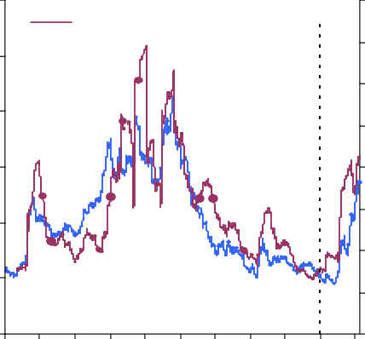

points

Spread (rhs)

Volatility (lhs)

Basis

(b)

250

200

150

100

50

0

points 1600

1400

1200

1000

800

600

400

200

0

# Chart 2: Global RMBS, CMBS and ABS issuance

US$ billions 3,000

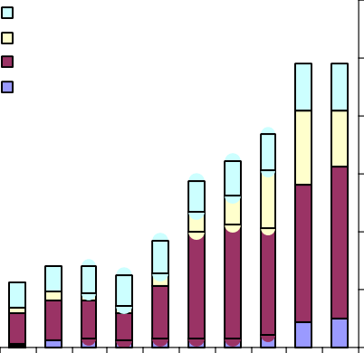

ABS excluding MBS RMBS Non Prime RMBS Prime CMBS

2,500

2,000

1,500

1,000

500

0

98 99 00 01 02 03 04 05 06 07 08

Sources: Merrill Lynch and Bank calculations.

(a) Option-adjusted spreads over government bond yields and 90-day annualised historical volatilities.

(b) 31 Dec. 2006.

# Chart 3: Housing problems spread to banks(a)

Source: Dealogic

# Chart 4: 3-month LIBOR spreads over expected policy rates(a)(b)

Index 104

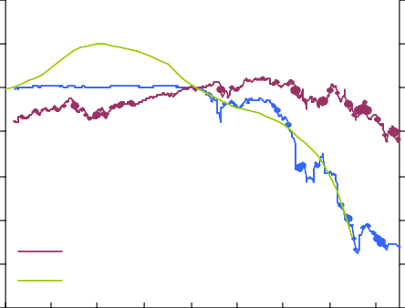

ABX index (BBB 2006H1) (rhs) Global bank equity index (rhs)

Case Shiller US property index (lhs)

102

100

98

96

94

92

90

Price / Index

140

120

100

80

60

40

20

0

Basis points

120

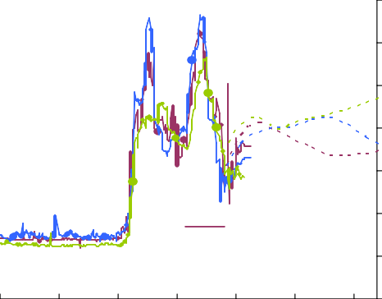

United States

United Kingdom

Euro area

100

80

60

40

20

0

Jan. Apr. Jul. Oct. Jan. Apr. Jul. Oct. Jan.

-20

2006

2007 08

Jan. Apr. Jul. Oct. Feb. May. Aug.

2007 08

Source: Datastream and JP Morgan Chase & Co.

(a) Equity and property indices rebased to Jan. 06 = 100.

Source: Bloomberg.

1. 3-month LIBOR spreads over 3-month overnight index swap (OIS) rates.
2. Solid lines show 3 month historical data, with dotted lines derived from forwards.

# Chart 5: Sub-prime mortgage losses Chart 6: Monoline CDS prices(a)

US$ billions

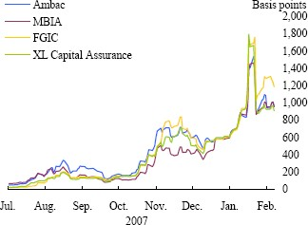350

300

250

200

150

100

50

0

Default losses to date

(a)

Projected losses (cashflow method)

Projected losses (market prices)

Writedowns to date

(b)

Sources: Bloomberg, Banks' financial statements and Bank calculations.

1. Estimated default losses to date on subprime securities based on cumulative delinquency rates.
2. Net of hedging.

Sources: Bank of England, Barclays Capital, Goldman Sachs, IMF and Moodys.

(a) Average of bid and offer premia of five-year senior debt CDS contracts.

# Chart 7: Key strands of FSF work

* Supervisory framework and oversight
  + Capital arrangements
  + Liquidity buffers
  + Risk management practices
  + Off balance sheet activities
* Underpinnings of the originate and distribute model
* Uses and role of credit ratings
* Market transparency
* Supervisory and regulatory responsiveness to risks
* Authorities’ ability to respond to crises